Stock Space

USER MANUAL

**Index**

* Welcome Page
* Login Page
* Dashboard
* Company
* Activate Company
* Edit Company
* New Company
* Category
* Edit Category
* Add New Category
* Sub Category
* Edit Sub Category
* Add Sub Category
* Product
* Edit Product
* Add Product
* Stock
* Edit Stock
* Repairs
* Customer Specific Repairs
* Edit Customer
* New Repair

**1.**

**Welcome Page**

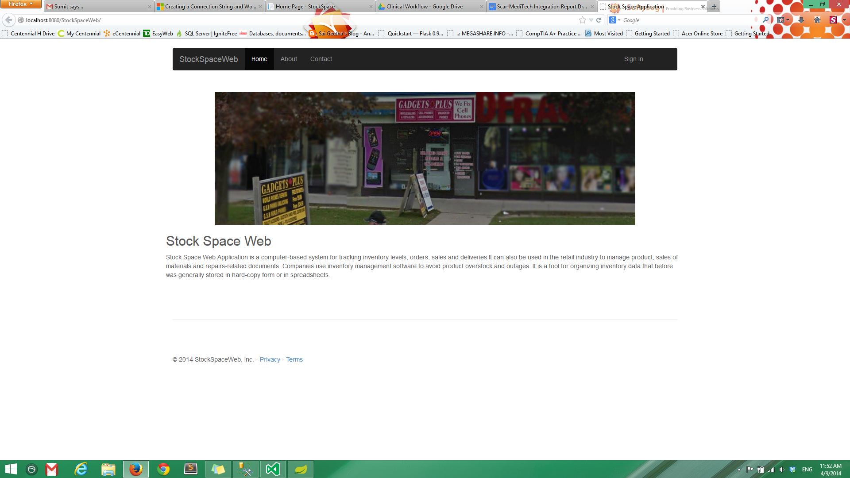

This is the home page of the system. There is a panoramic view of the **"Gadgets Plus"** store and a brief information about the system below. On the top of the page there is a title bar which contains the name of the system to the left and there are options for Home, About and Contact which displays the respective information about the store. On the extreme right there is a link to Sign in into the system. Clicking on the link take the user to the next page.

**2.**

**Login Page**

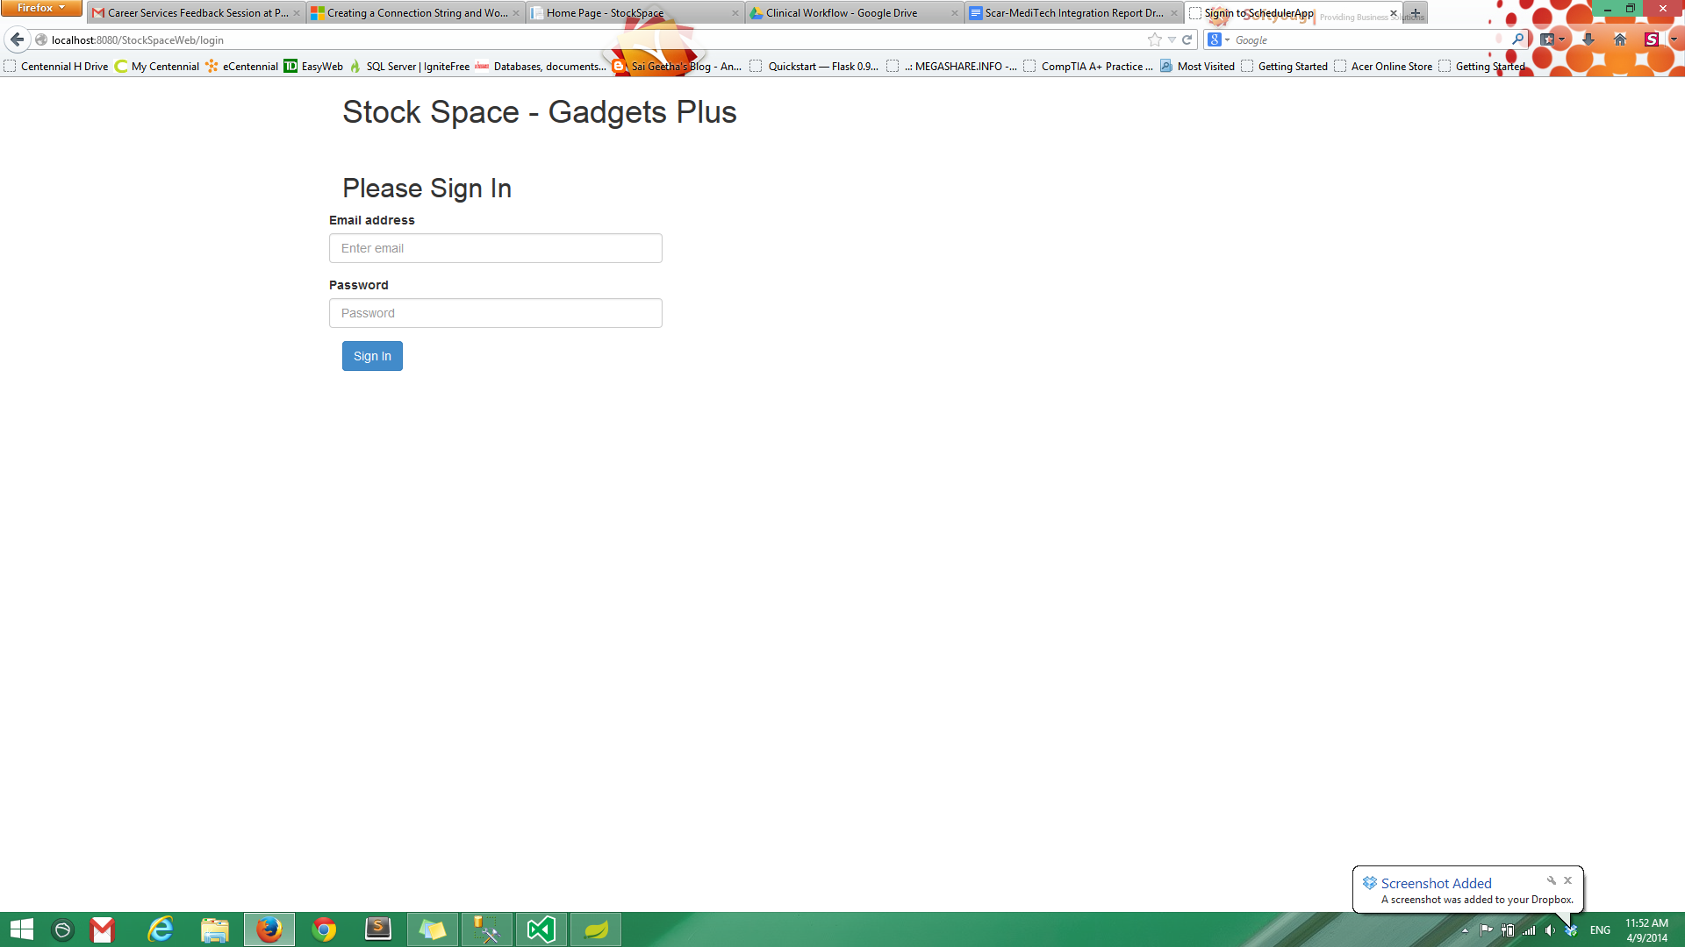

This is the login page of the system. The user has to sign in using his email address and his chosen password. Once the credentials are verified the user is taken to the dashboard of the system.

**3.**

**Dashboard**

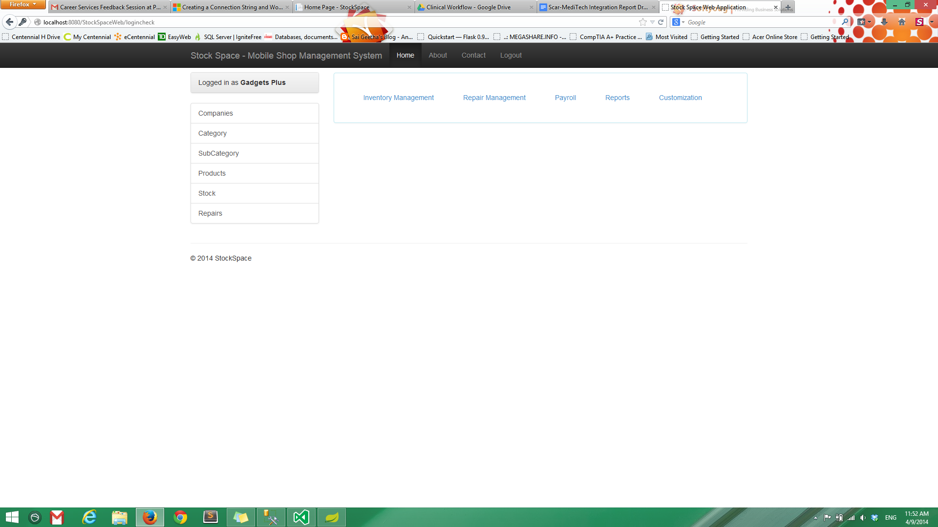

This is the dashboard of the system which contains each and every option available to the user. On top all the modules of the system are provided which are Inventory Management, Repair Management, Payroll, Reports and Customisation. Clicking on these links takes the user to the respective functionalities. To the left of the page six options of Companies, Category, Subcategory, Products, Stock and Repairs are stacked. These options provide easy navigation support to locate products available for sales and tracking the products taken in for repairs. On the title bar there is Logout function available to sign out of the system.

**4.**

**Company**

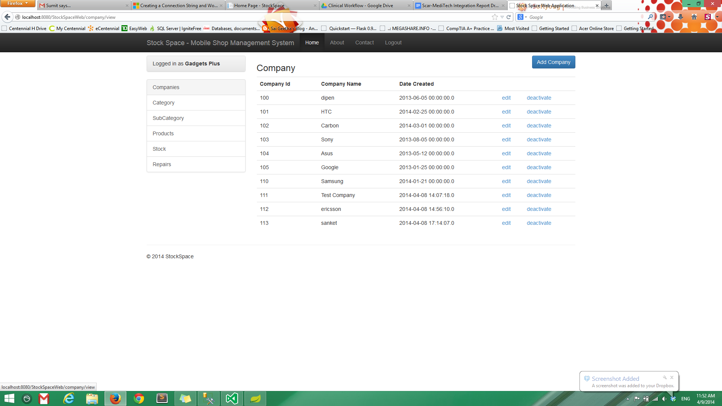

This page shows the inventory module of the system. The data displayed is of all the companies whose products are available for sales. Each company is classified using a unique company id followed by the company name and the date on which its entry was created in the system. For every company there are options to edit the company particulars and to either activate or deactivate the company. On the top right corner of the page there is an option to add new companies.

**5.**

**Activate Company**

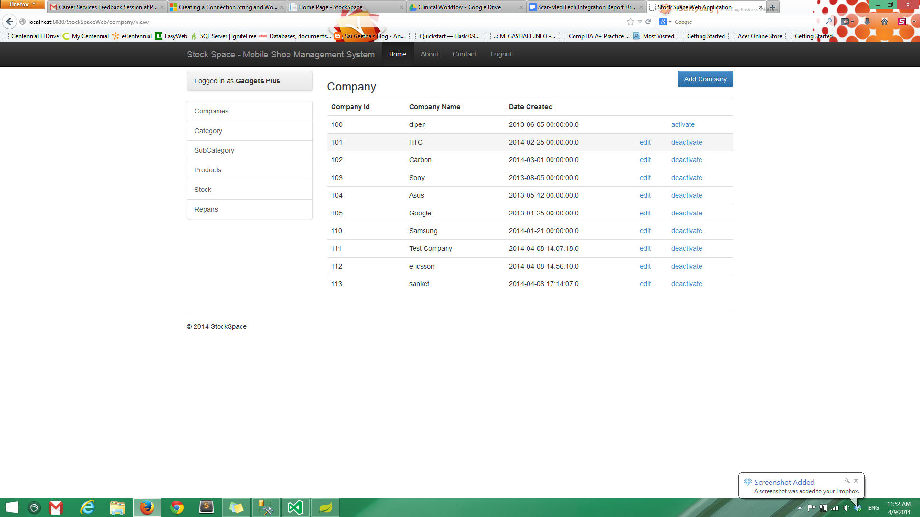

This page shows the activation and deactivation options available for a company. As it is evident that for the company name dipen the activate option is highlighted, that is because it has been deactivated. Other available companies like HTC are still activated that's why their information can be edited and of course that's why the deactivate option is available for them.

In case the store decides to discontinue the products of a company it can be deactivated. Once the products are available for sales again it can be activated again.

**6.**

**Edit Company**

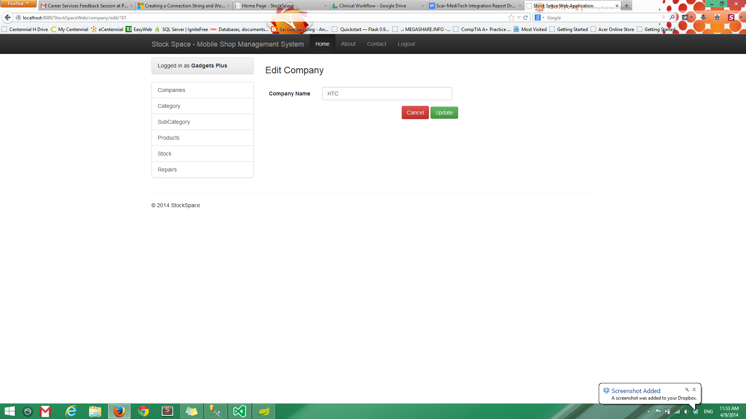

For each company listed in the system the information can be edited by pressing the edit button in front of the company name. Once this button is pressed the above page appears. The editable information which is basically the name of the company can be corrected and updated by pressing the Update button. The changes are highlighted in the list automatically.

**7.**

**New Company**

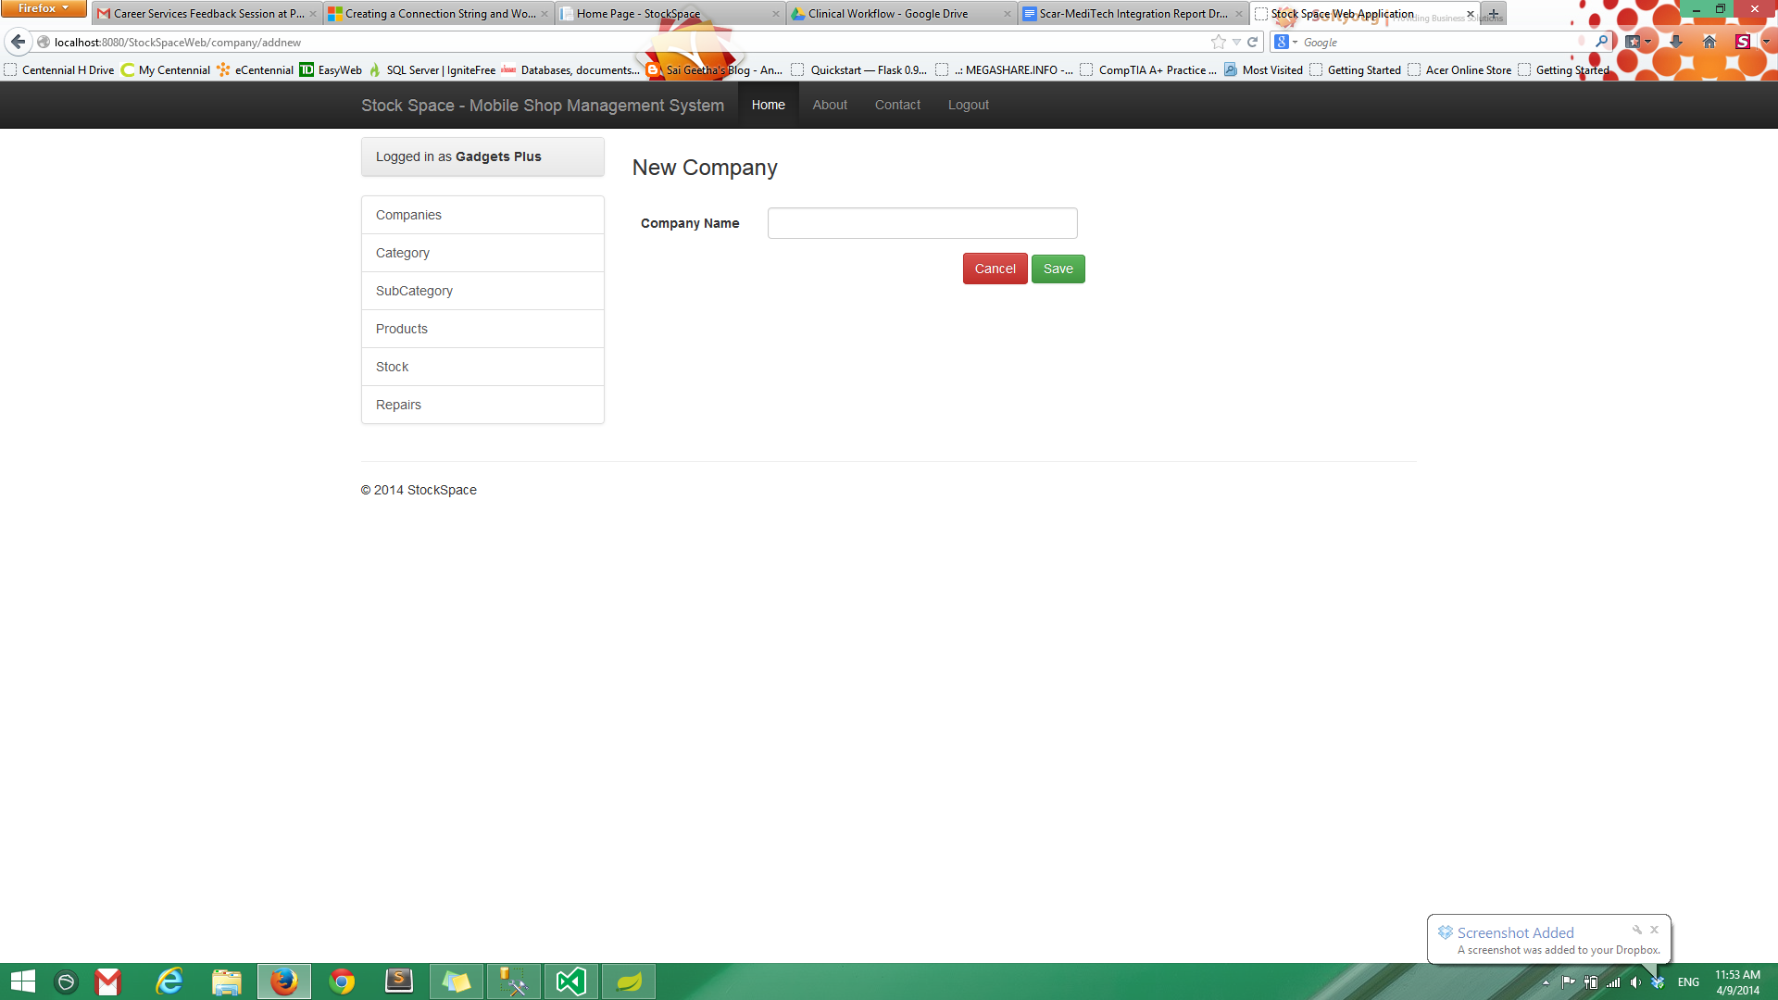

When the store decides to sell the products from a new company the respective company has to be listed in the system. This can be done by pressing the Add Company button. On pressing this button the above screen appears. The name of the new company has to be entered in the text box provided. On pressing the save button the new company is added to the list of companies whose products are available in store.

**8.**

**Category**

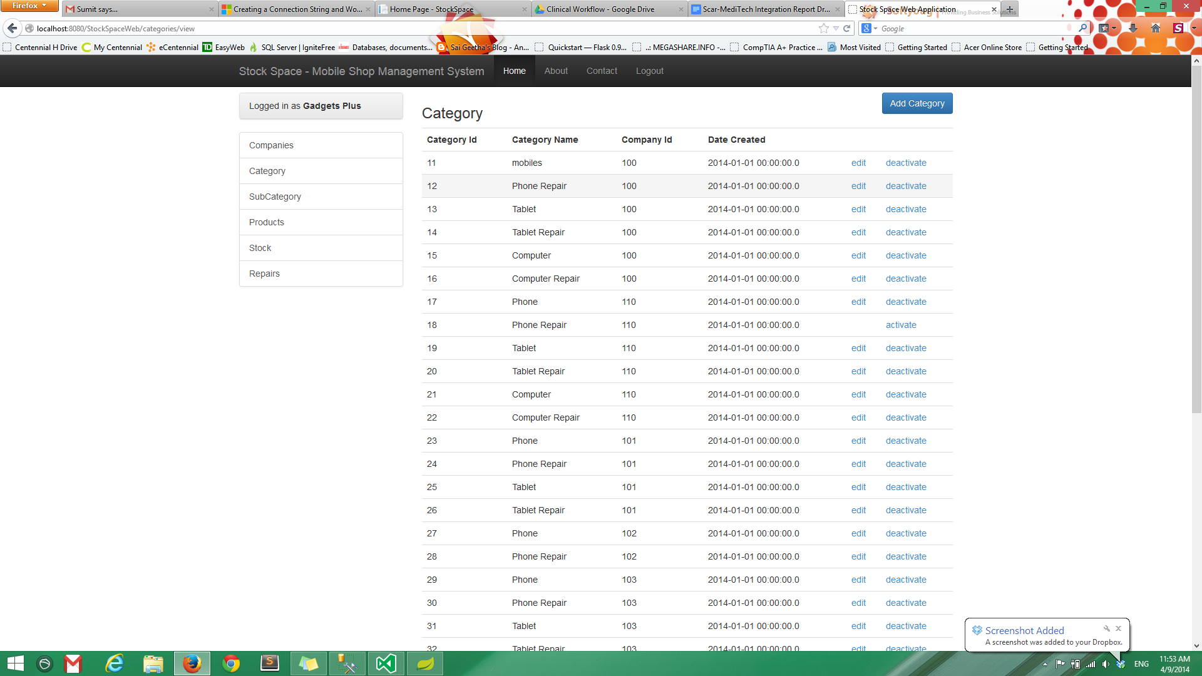

The products in the store either for sale or given for repairs have to be classified into different categories. The above page displays these categories. Each category is identified with a unique category id followed by a category name. There is a company id which helps to identify the company of whose product is being referred to. The date on which the category is created is also provided for every category. Every category can be edited and activated or deactivated as per requirement. For adding a new category there is a Add Category button on the top right corner of the page.

**9.**

**Edit Category**

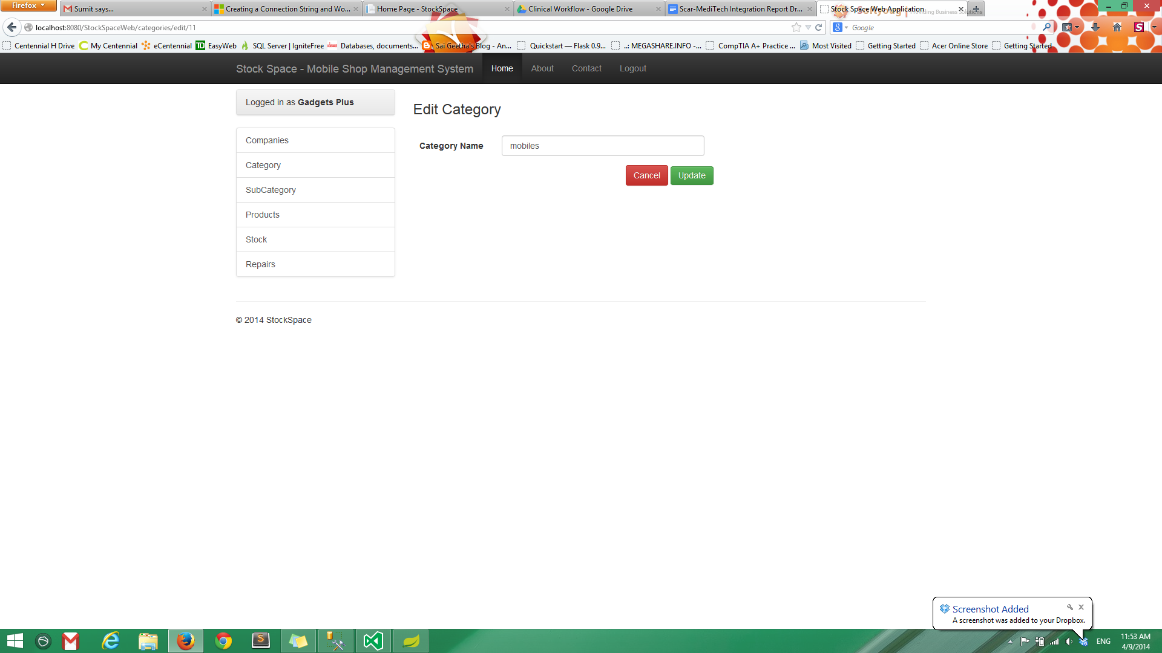

For every category listed in the system, its particulars can be edited by pressing the edit link in front of the category name. On pressing edit the above page appears. Here can category name can be edited. On pressing the update button the updated category will appear in the category list.

**10.**

**Add New Category**

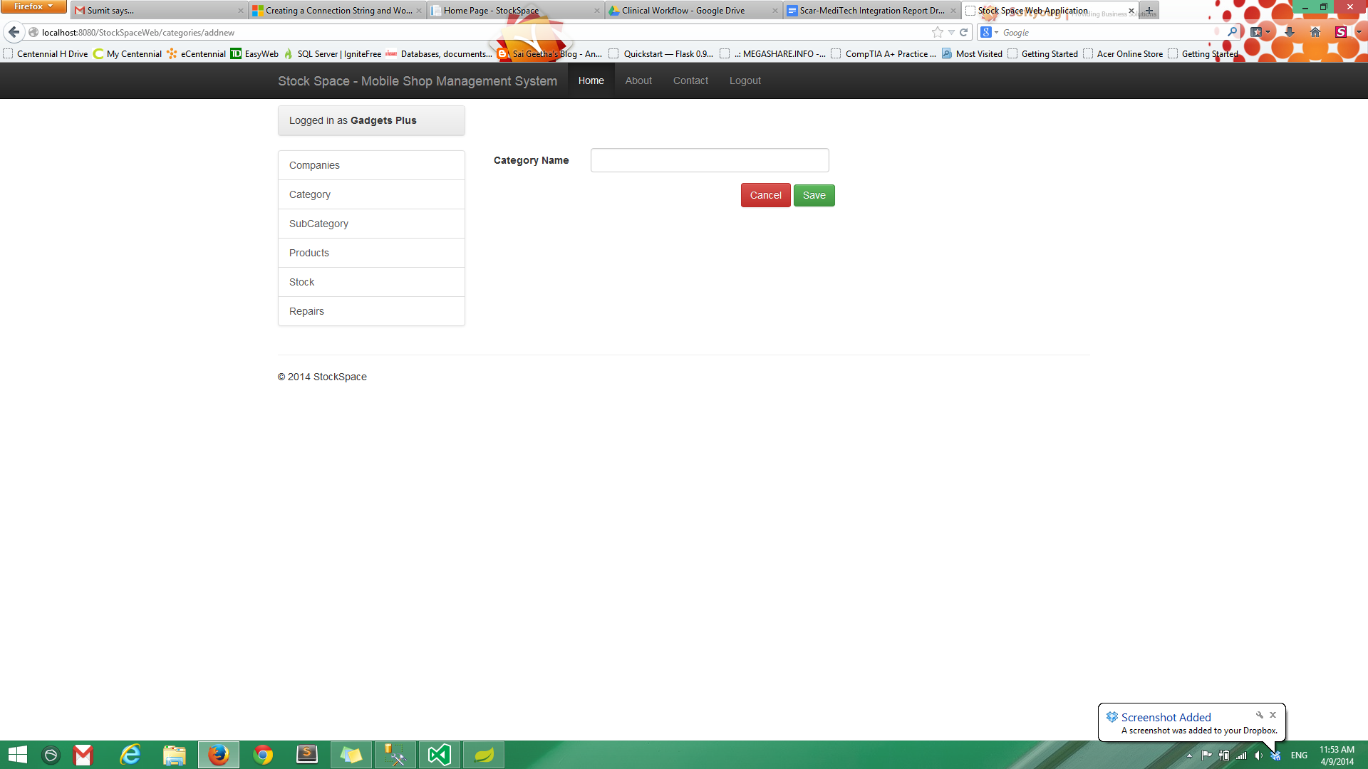

A new category can be added in the system by pressing the Add Category button. On pressing this button The above page appears. Here the category name can be entered in the given text box. On pressing the save button the new category will be added in the list along with an auto generated category id. Also the date and time on which the category is created will appear automatically.

**11.**

**Sub Category**

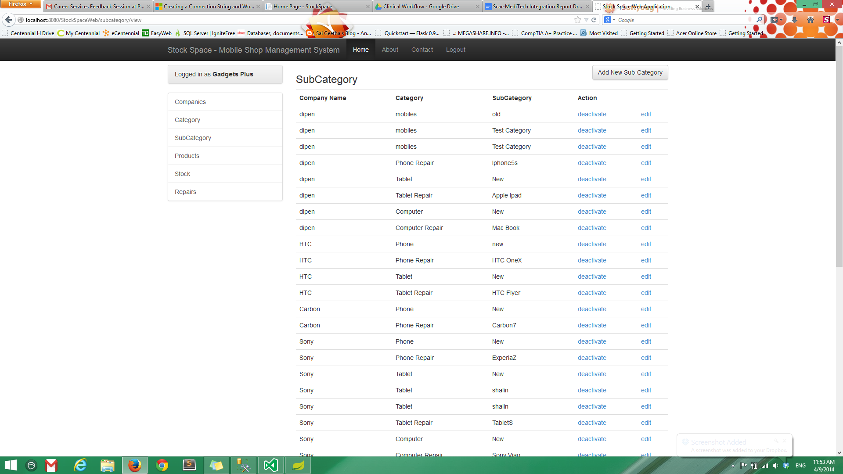

In order to make navigation to the desired product easier each category is further divided into sub categories. The above page lists these sub categories. It provides the details of the company of whose product is being referred to. Then, there is the category which tells that the product is a mobile or a tablet. The sub category further describes that the product is an iPhone, a Mac Book or a Sony Xperia. These sub categories can be edited and activated or deactivated as per requirement. A new sub category can be added by pressing the Add Sub Category button on the top right corner of the page.

**12.**

**Edit Sub Category**

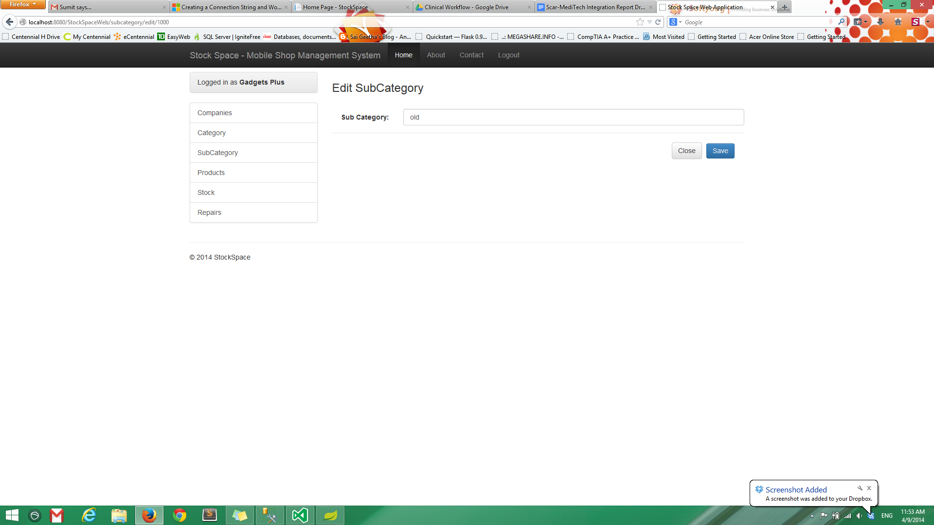

For making any kind of changes to an existing sub category the edit option can be used. On pressing edit the above page appears. Here the information can be corrected by entering the right information in the text box provided. On pressing the save button the corrected information will appear in the list of sub categories.

**13.**

**Add Sub Category**

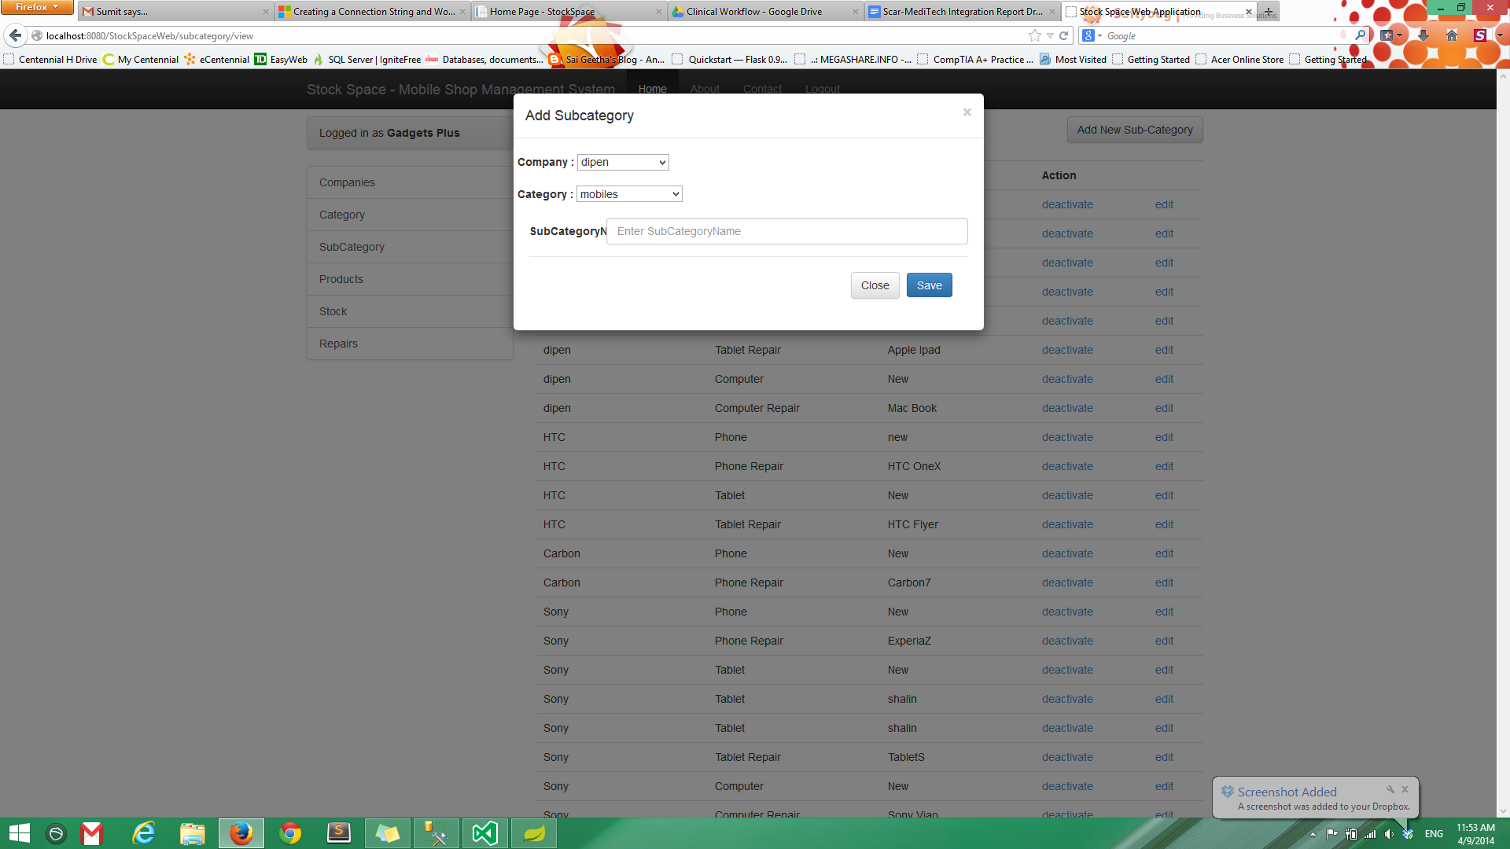

The Add Sub Category button allows the user to add new sub category to the system. On pressing this button the above page appears. Here the user has to first select the Company and the Category to which the new sub category belongs from the drop down list. Then, the name of the sub category has to be typed in the text box. On pressing the save button the new sub category appears in the list of the sub categories.

**14.**

**Product**

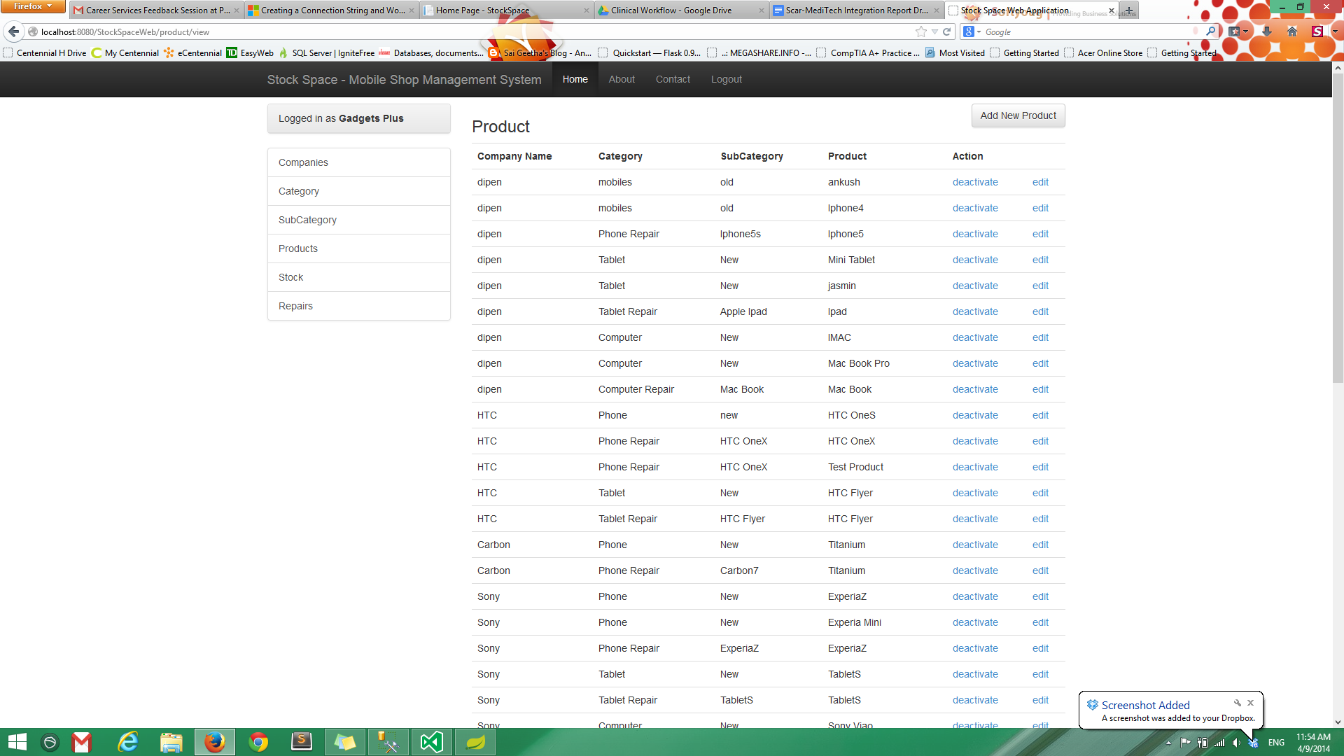

All the products which are available in the store either for sales or for repair are listed on the above page along with their companies, categories and sub categories. This page provides the finest level of details for every product present in store about its origin. The information for each product can be edited and each product can be activated and deactivated as per requirement. For adding a new product the Add New Product button is provided in the top right corner of the page.

**15.**

**Edit Product**

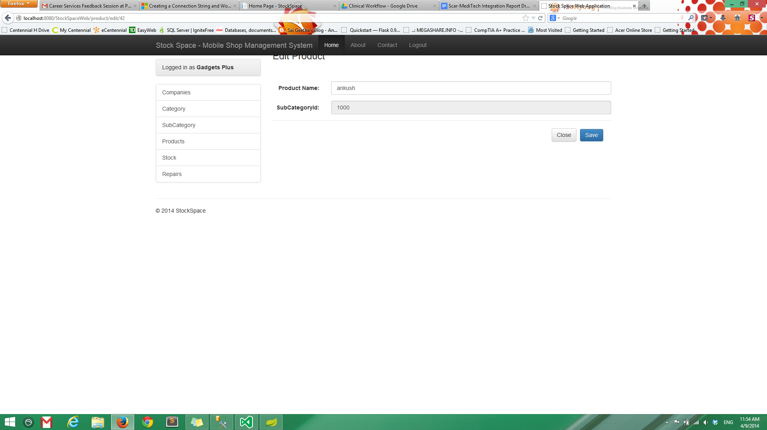

On pressing the edit button for a product the product information can be altered. The above page appears when editing a product. The corrected product name and sub category id can be entered in the respective text boxes. On pressing the save button the corrected information appears in the product list.

**16.**

**Add Product**

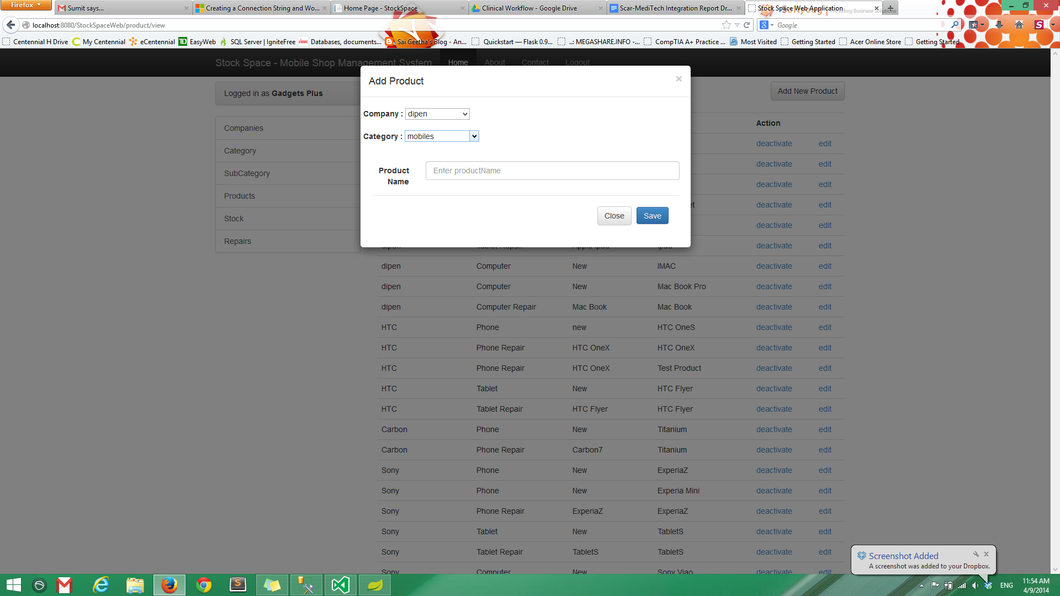

When a new product is introduced in the store it can be added by pressing the Add New Product button. On pressing this button the above page appears. Here the user has to select the company and category of the new product from a drop down list. The product name can be entered in the text box provided. On pressing the save button the new product is added in the list of products.

**17.**

**Stock**

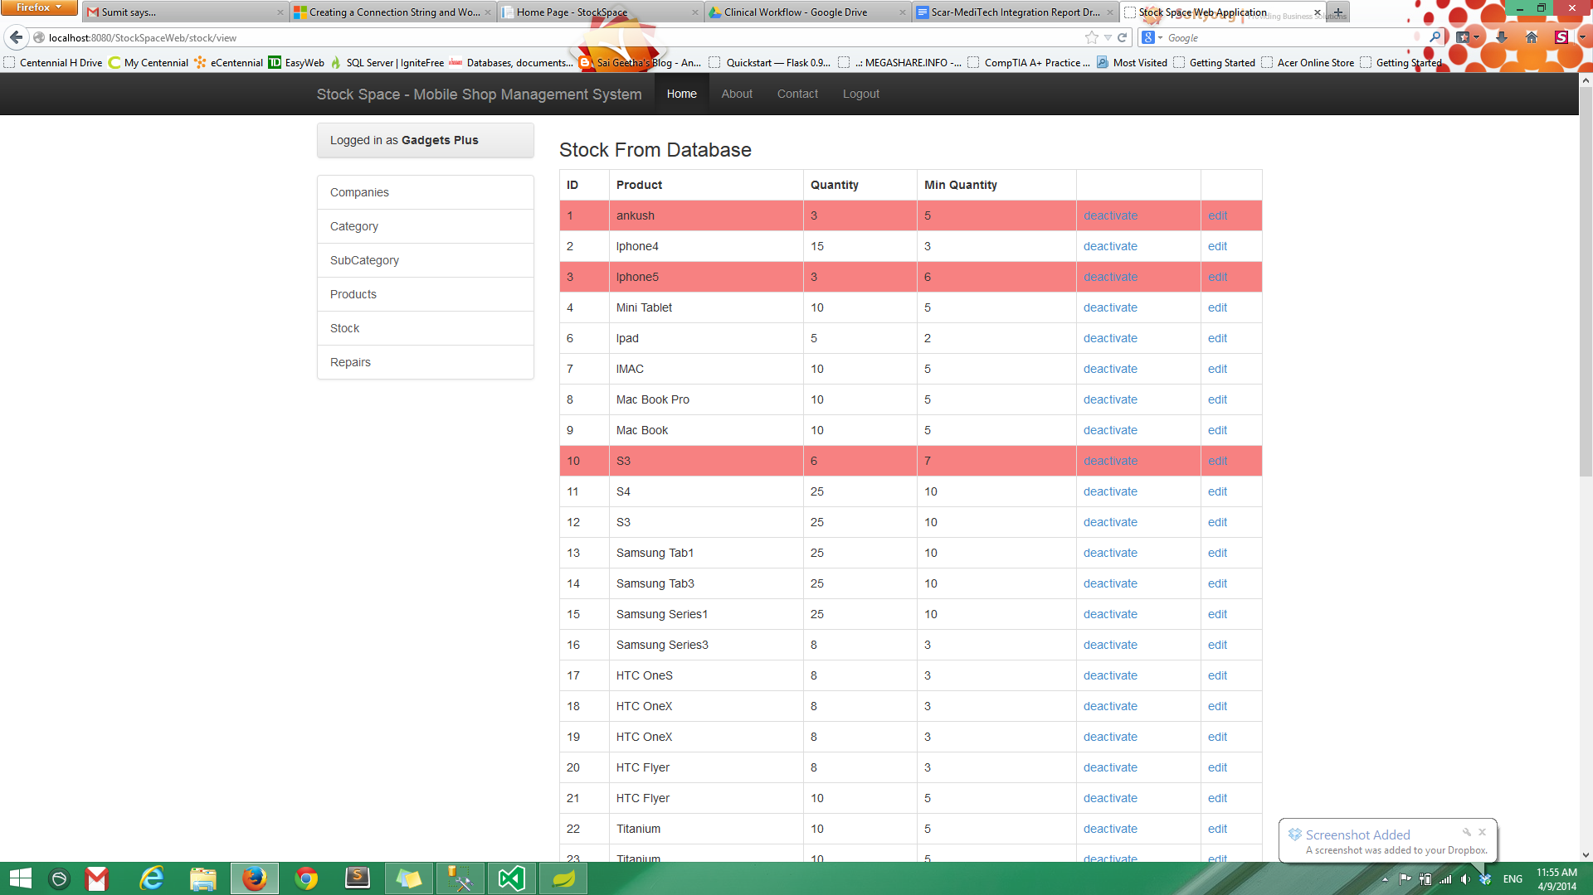

The stock option provides detailed information of all the products available in store for sales. Every product is differentiated from the other by a unique id. The user can see the quantity available for a product and the minimum quantity to be maintained every time. If the available quantity drops below the minimum quantity, the product is automatically highlighted so that the owner can order supplies. The information for every product can be edited and it can be activated or deactivated as per requirement.

**18.**

**Edit Stock**

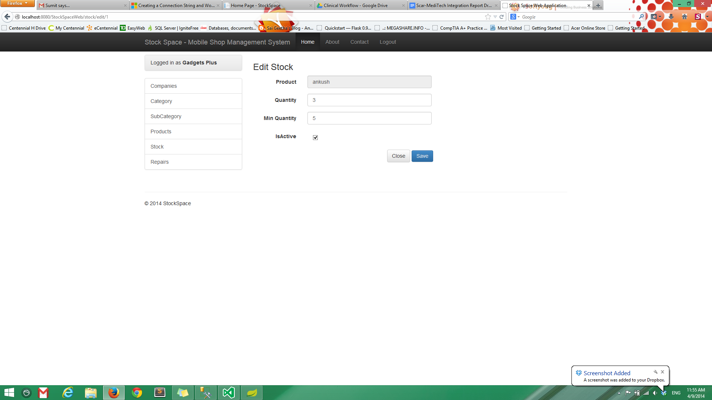

To change the information about any product available in store the edit option is available for every listed product. On pressing the edit option the above page appears. Here the name of the product can be changed and the quantity and minimum quantity can be adjusted. There is a check box which if ticked indicates that the product is active and available.

**19.**

**Repairs**

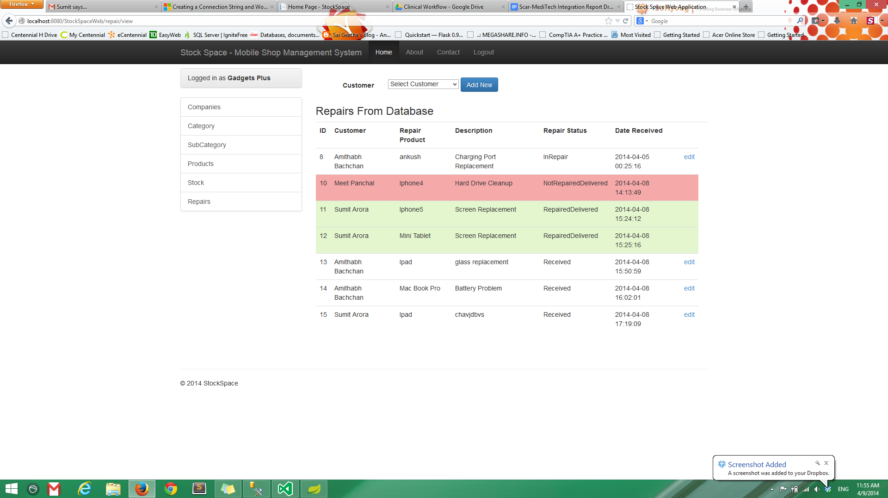

The Repairs option displays the list of all the products which are in store for repairs. Every entry consists of a unique id followed by the customer name, the product taken for repair and brief description of product. For every product the repair status is updated constantly whether it's Received, In Repair, Shipped etc. The date on which the product arrived is also listed. On top of the page there is a drop down list of all the customers who have given their products for repairs. If a new product arrives the name of the customer can be added by pressing the Add New button on top.

**20.**

**Customer Specific Repairs**

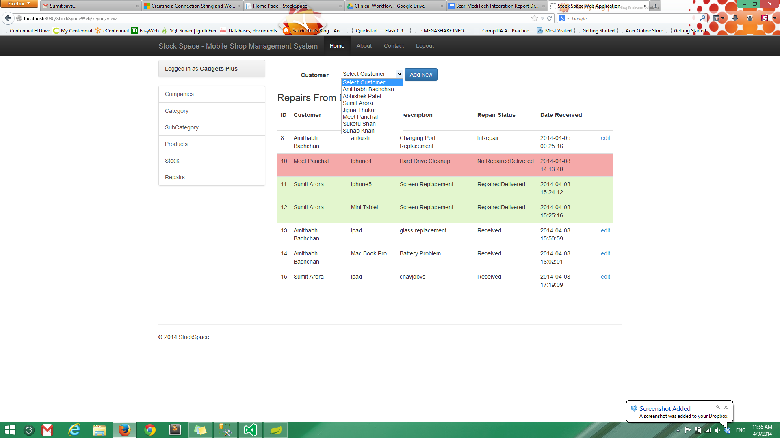

For viewing the products shipped by a certain customer the name of the product can be selected from the drop down list. Once the name is selected the list is filtered for that particular customer only.

**21.**

**Edit Customer**

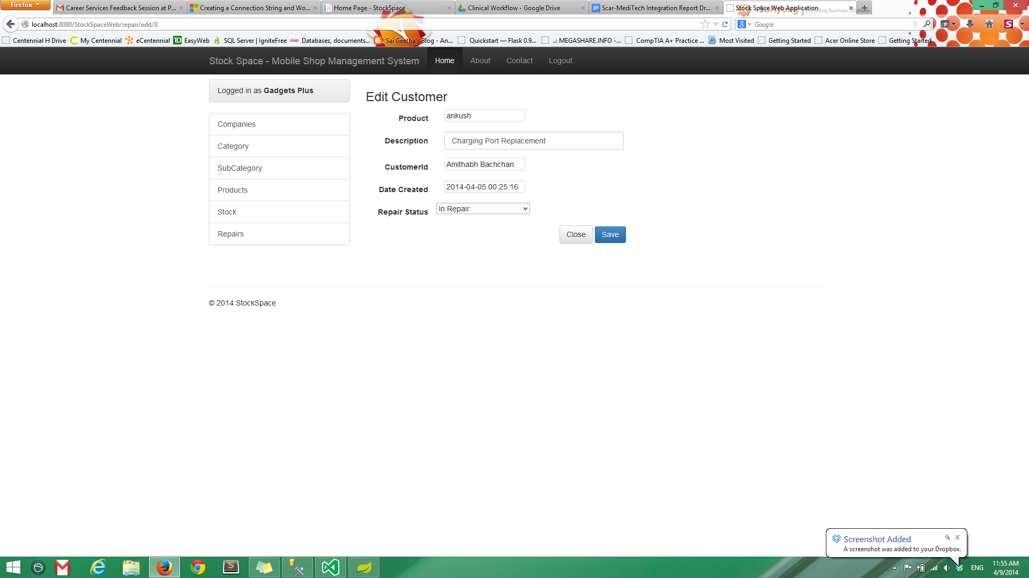

For changing the information about any customer, the edit option is available for every entry. On pressing edit the above page appears. There are text boxes provided for Product name, Description, Customer Id and Date created. The repair statuses are provided in the form of a drop down list. The correct information can be entered and it will be updated by pressing the Save button.

**22.**

**New Repair**

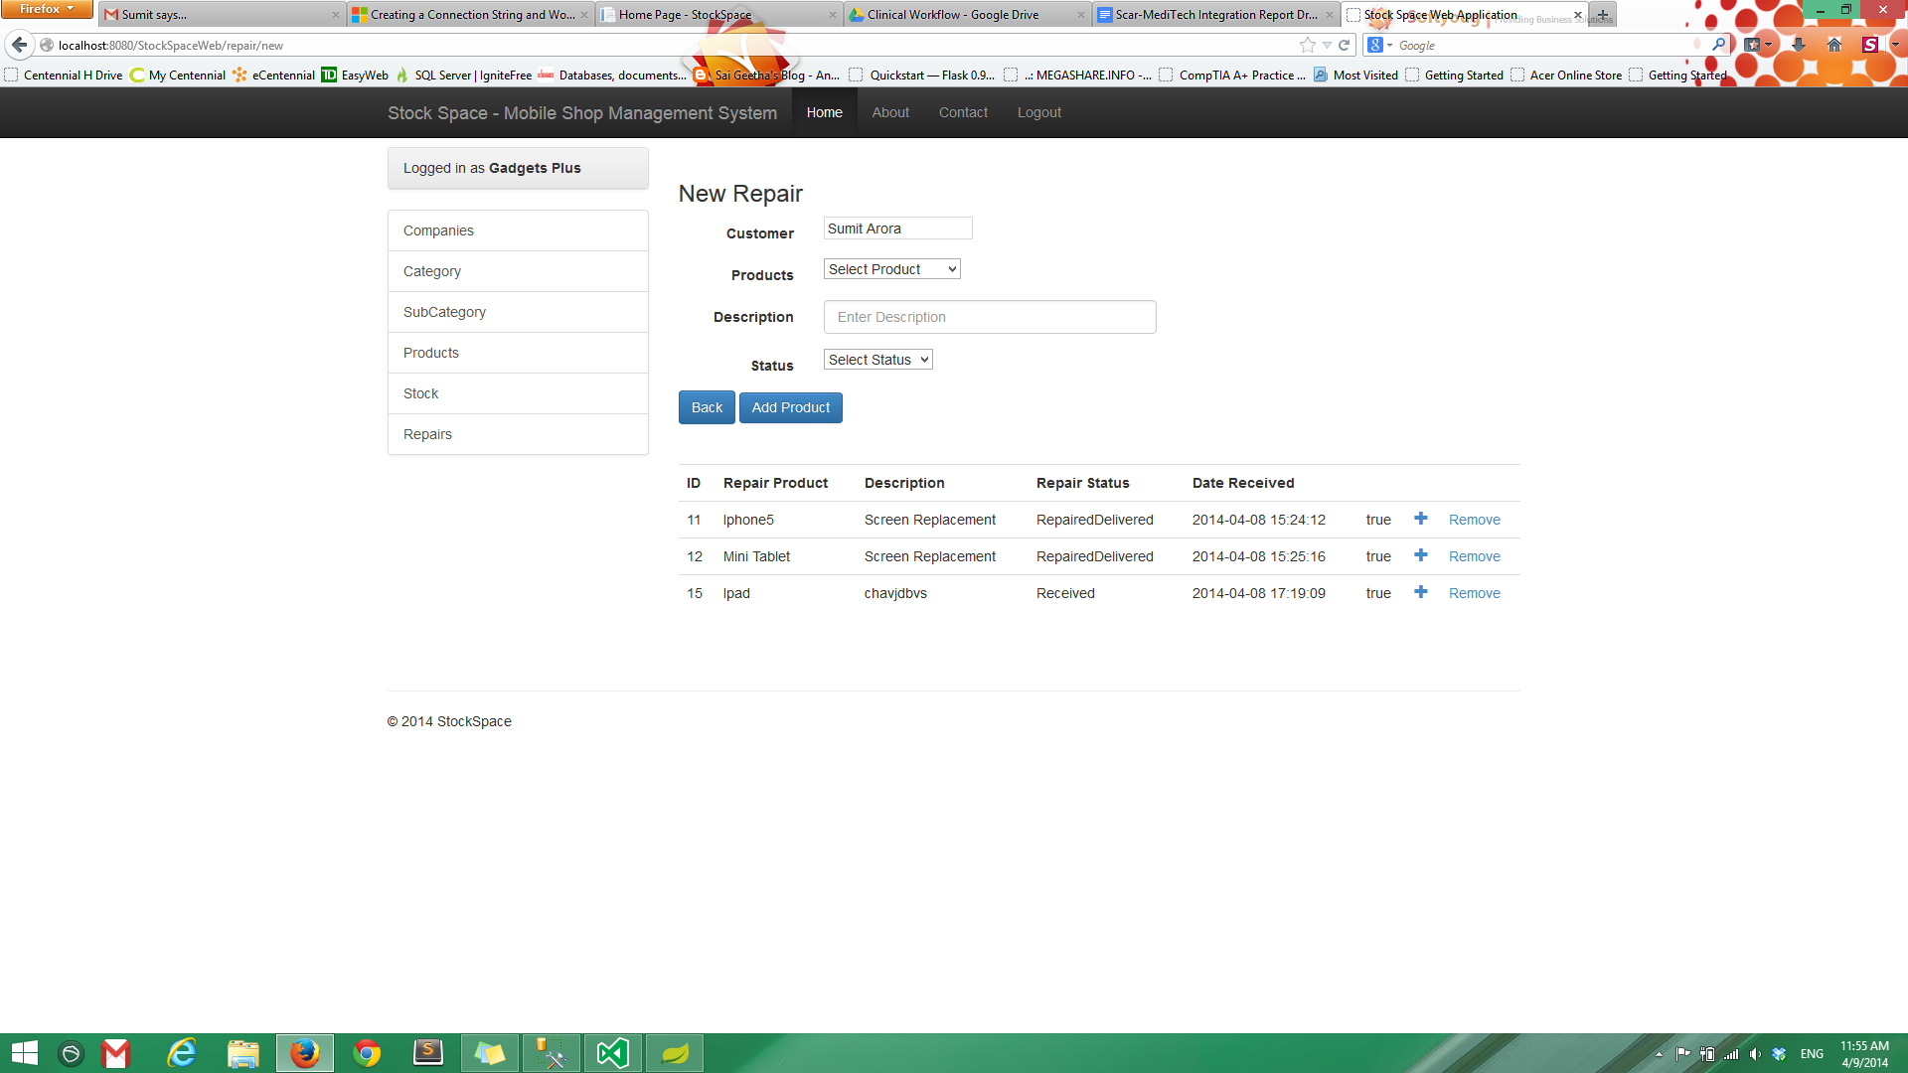

When a new product arrives for repair the system can be updated by pressing the Add New button on top of repairs list. On pressing the Add New button the above page appears. The name of the customer can be entered in the text box and the product shipped can be selected from the drop down list. There is a text box to provide a brief description about the product. The status of the product can be set or updated from the drop down list. After all the details has been entered the Add Product button can be pressed to update the list of repairs.